The Playwright framework is a powerful, open-source automation library developed by Microsoft for end-to-end testing and browser automation. It supports multiple browsers (Chromium, WebKit, Firefox) and languages (JavaScript/TypeScript, Python, Java, C#), making it versatile for testing modern web applications.

Playwright Framework Details
- Purpose: Playwright is designed for automating web browsers, primarily for end-to-end testing, web scraping, and browser-based task automation.
- Supported Browsers: Chromium (Chrome, Edge), WebKit (Safari), Firefox.
- Languages: JavaScript/TypeScript (Node.js), Python, Java, C#.
- Key Features:
  - Cross-browser support: Consistent API across all major browsers.
  - Auto-waiting: Automatically waits for elements to be ready, reducing flakiness.
  - Headless and Headful Modes: Run tests in headless (no UI) or headful (visible browser) modes.
  - Network Interception: Mock or monitor network requests.
  - Device Emulation: Simulate mobile devices, geolocation, and permissions.
  - Parallel Execution: Run tests in parallel for faster execution.
  - Tracing and Debugging: Built-in tools like screenshots, videos, and trace viewers for debugging.
  - WebSocket and Modern Web Support: Handles WebSocket, Shadow DOM, and modern web features natively.
  - Playwright Test: A dedicated test runner for reliable, parallel test execution.
- License: Apache 2.0 (open-source).
- Platforms: Windows, macOS, Linux.
- Use Cases: End-to-end testing, UI testing, API testing, web scraping, and browser automation.

Differences from Selenium
Feature | Playwright | Selenium
Browser Support | Chromium, WebKit, Firefox (native support, no additional drivers needed). | Chrome, Firefox, Safari, Edge (requires browser-specific drivers, e.g., WebDriver).
Architecture | Single process with WebSocket-based communication for better performance. | Client-server model with WebDriver, which can introduce latency.
Auto-waiting | Built-in auto-waiting for elements, reducing flaky tests. | Manual waits (implicit/explicit) often required, increasing flakiness risk.
Speed | Faster due to direct browser control and parallel execution. | Slower due to WebDriver communication overhead.
Language Support | JavaScript/TypeScript, Python, Java, C#. | Supports more languages (e.g., Ruby, PHP, in addition to Java, Python, etc.).
Mobile Emulation | Built-in device emulation for mobile testing. | Limited mobile emulation, often requiring third-party tools like Appium.
Headless Mode | Seamless headless and headful modes with consistent behavior. | Headless support varies by browser and can be less reliable.
Network Interception | Robust support for mocking and intercepting network requests. | Limited network interception capabilities, less flexible.
API Testing | Native support for API testing alongside browser automation. | Primarily browser-focused; API testing requires additional libraries.
Debugging Tools | Advanced tracing, screenshots, videos, and Playwright Inspector. | Basic debugging, relies on external tools for advanced features.
Community and Ecosystem | Newer, growing community; fewer third-party integrations. | Mature, large community with extensive integrations and plugins.
Key Takeaway: Playwright is more modern, faster, and reliable for cross-browser testing with built-in features like auto-waiting and network interception. Selenium is more mature, supports more languages, and has a broader ecosystem but requires more setup and manual handling.

Advantages Over Other Frameworks
Compared to other automation frameworks like Cypress, Puppeteer, and WebdriverIO:
- Cross-browser Support:
  - Unlike Cypress (Chromium-only) or Puppeteer (Chromium-focused), Playwright supports Chromium, WebKit, and Firefox natively.
  - WebdriverIO relies on Selenium’s WebDriver, which can be slower and less reliable.
- Auto-waiting:
  - Playwright’s auto-waiting reduces flaky tests compared to Cypress, which requires manual waits in some cases, or Selenium’s explicit waits.
- Modern Web Features:
  - Handles Shadow DOM, WebSocket, and modern APIs better than Selenium and WebdriverIO.
  - Cypress struggles with multi-tab scenarios, while Playwright supports them natively.
- Performance:
  - Playwright’s WebSocket-based architecture is faster than Selenium’s WebDriver protocol and more efficient than Cypress for cross-browser tests.
- Built-in Tools:
  - Playwright offers tracing, screenshots, videos, and a test runner (Playwright Test) out of the box, reducing reliance on external tools compared to Selenium or WebdriverIO.
  - Cypress has a strong dashboard but is limited to JavaScript and lacks Playwright’s cross-browser flexibility.
- Language Flexibility:
  - Supports multiple languages (unlike Cypress, which is JavaScript-only) and is easier to set up than Selenium’s driver-based approach.
- Mobile and API Testing:
  - Built-in device emulation and API testing capabilities surpass Selenium and match or exceed Cypress and Puppeteer.
Summary: Playwright combines the best of Puppeteer’s speed, Cypress’s developer experience, and Selenium’s cross-browser support, with fewer setup hassles and modern features.

Playwright Architecture
Playwright’s architecture is designed for performance and reliability:
- Client-Server Model:
  - The client (test script in Node.js, Python, etc.) communicates with the browser via a WebSocket connection.
  - Unlike Selenium’s HTTP-based WebDriver, WebSocket provides low-latency, bidirectional communication.
- Components:
  - Playwright API: The user-facing API (e.g., page.goto(), page.click()) available in multiple languages.
  - Browser Server: A lightweight server process that manages browser instances (Chromium, WebKit, Firefox).
  - Transport Layer: WebSocket protocol for efficient communication between the client and browser server.
  - Browser Context: Isolated environments (like incognito mode) for parallel testing.
  - Page: Represents a single browser tab or page, with APIs for navigation, interaction, and inspection.
- Execution Flow:
  - The test script calls Playwright APIs.
  - Commands are sent to the browser server via WebSocket.
  - The browser server interacts with the browser engine (e.g., Chromium’s Blink, WebKit, or Gecko for Firefox).
  - Responses (e.g., DOM updates, network events) are sent back to the client.
- Key Benefits:
  - Direct browser control eliminates the need for external drivers (unlike Selenium).
  - Parallel execution of browser contexts improves scalability.
  - Auto-waiting and event listeners reduce test flakiness.
Image for Architecture typical Playwright architecture:
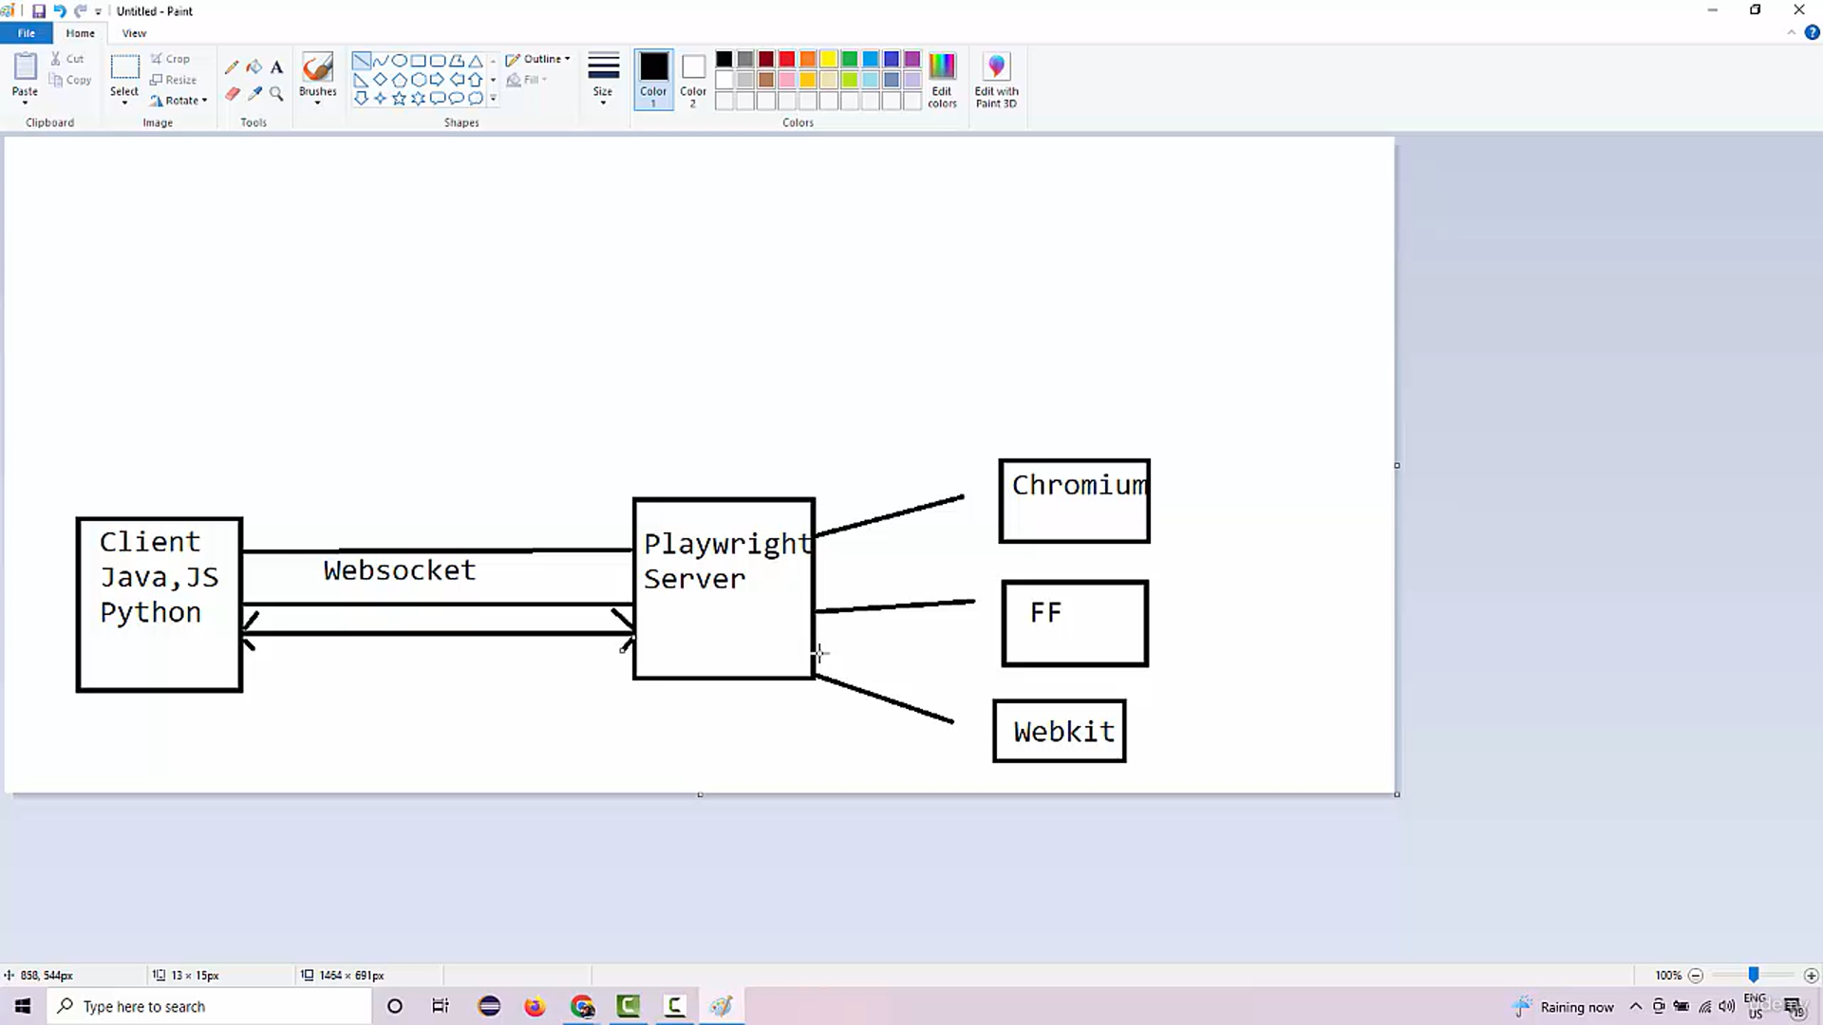

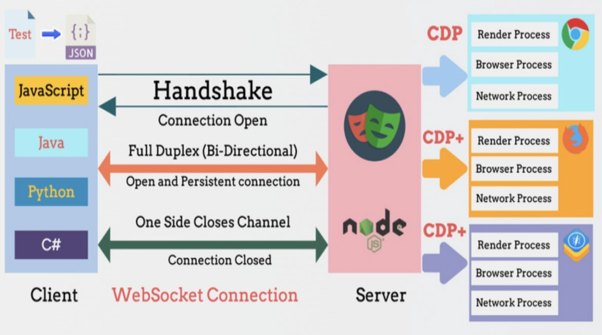
- Diagram Description:
  - A box labeled “Test Script” (in Node.js, Python, etc.) connects to a “Playwright API” box.
  - The API communicates via a WebSocket arrow to a “Browser Server” box.
  - The Browser Server connects to multiple browser instances (Chromium, WebKit, Firefox).
  - Each browser instance contains multiple “Browser Contexts,” each with multiple “Pages.”
  - Arrows show bidirectional communication between components.

Code Examples
Below are examples in different languages to demonstrate Playwright’s usage for common tasks.
JavaScript (Node.js) - Basic Navigation and Interaction
const { chromium } = require('playwright');

(async () => {
const browser = await chromium.launch({ headless: false });
const page = await browser.newPage();
await page.goto('https://example.com');
await page.click('a[href="/about"]'); // Clicks a link
await page.screenshot({ path: 'screenshot.png' });
await browser.close();
})();
Python - Form Filling and Network Interception
from playwright.sync_api import sync_playwright

with sync_playwright() as p:
browser = p.chromium.launch(headless=False)
page = browser.new_page()
page.goto('https://example.com/login')
page.fill('input[name="username"]', 'user123')
page.fill('input[name="password"]', 'pass123')
page.click('button[type="submit"]')

# Intercept network requests
page.on('request', lambda request: print(f'Request: {request.url}'))
page.goto('https://example.com/dashboard')
browser.close()
Java - Device Emulation
import com.microsoft.playwright.*;

public class PlaywrightExample {
public static void main(String[] args) {
try (Playwright playwright = Playwright.create()) {
Browser browser = playwright.chromium().launch(new BrowserType.LaunchOptions().setHeadless(false));
BrowserContext context = browser.newContext(new Browser.NewContextOptions()
.setViewportSize(375, 667) // iPhone 11 viewport
.setDeviceScaleFactor(2)
.setIsMobile(true));
Page page = context.newPage();
page.navigate("https://example.com");
page.click("a[href='/contact']");
page.screenshot(new Page.ScreenshotOptions().setPath(Paths.get("mobile-screenshot.png")));
browser.close();
}
}
}
Playwright Test (JavaScript) - End-to-End Test
const { test, expect } = require('@playwright/test');

test('should navigate to example.com and check title', async ({ page }) => {
await page.goto('https://example.com');
await expect(page).toHaveTitle(/Example Domain/);
await page.click('a[href="/about"]');
await expect(page).toHaveURL('https://example.com/about');
});
Playwright Architecture: Deep Dive
Playwright's architecture is a client-server model optimized for modern web automation and testing. It abstracts browser complexities while providing fine-grained control over browser instances, contexts, and pages.
1. Components of Playwright Architecture
- Client (Playwright API):
  - The Playwright API is the user-facing interface available in supported languages (JavaScript/TypeScript, Python, Java, C#).
  - It provides high-level methods like page.goto(), page.click(), and page.evaluate() that abstract browser interactions.
  - The API is implemented as a language-specific library (e.g., @playwright/test for Node.js, playwright for Python) that translates user commands into protocol messages.
  - Implementation Details: Each language binding is a thin wrapper over a common protocol, ensuring consistent behavior across languages. For example, the JavaScript client uses Node.js, while the Python client leverages asyncio or synchronous APIs.
- Browser Server:
  - The Browser Server is a lightweight process that manages browser instances (Chromium, WebKit, Firefox).
  - It acts as an intermediary between the Playwright API and the browser engine, handling tasks like launching browsers, managing contexts, and forwarding commands.
  - Implementation Details: The Browser Server is written in JavaScript (Node.js) and runs as a separate process for each browser type. It embeds browser binaries (e.g., Chromium, WebKit) and communicates with them via their native debugging protocols (e.g., Chrome DevTools Protocol for Chromium).
- Transport Layer (WebSocket):
  - Playwright uses WebSocket for bidirectional, low-latency communication between the client (test script) and the Browser Server.
  - Unlike Selenium’s HTTP-based WebDriver protocol, WebSocket allows persistent connections, reducing overhead and enabling real-time event streaming.
  - Implementation Details:
    - The WebSocket connection is established when a browser is launched (e.g., chromium.launch()).
    - Commands (e.g., navigate, click) are serialized as JSON messages and sent over WebSocket.
    - Responses, events (e.g., page.on('load')), and errors are streamed back to the client.
    - The protocol is asynchronous, allowing Playwright to handle multiple browser contexts and pages concurrently.
- Browser Context:
  - A Browser Context is an isolated environment within a browser instance, similar to an incognito window.
  - Each context has its own cookies, cache, local storage, and permissions, enabling parallel testing without interference.
  - Implementation Details:
    - Contexts are managed by the Browser Server, which allocates resources (e.g., memory, CPU) for each context.
    - Playwright supports creating multiple contexts within a single browser instance, reducing resource overhead compared to launching separate browsers.
    - Contexts are lightweight because they share the browser’s rendering engine but maintain isolated state.
- Page:
  - A Page represents a single browser tab or window within a Browser Context.
  - It provides APIs for DOM manipulation, navigation, and event handling.
  - Implementation Details:
    - Pages are managed by the Browser Server and communicate with the browser engine via the same WebSocket channel.
    - Each page maintains its own DOM tree, event listeners, and network stack, but shares the context’s settings (e.g., viewport, cookies).
- Browser Engine:
  - The browser engine (Chromium’s Blink, WebKit, or Firefox’s Gecko) is the core rendering and JavaScript execution environment.
  - Playwright embeds patched versions of these engines to enable advanced features like auto-waiting and network interception.
  - Implementation Details:
    - Playwright uses the Chrome DevTools Protocol (CDP) for Chromium, a custom WebKit protocol, and a modified Gecko protocol for Firefox.
    - Patches to browser engines allow Playwright to hook into low-level browser events (e.g., DOM updates, network requests) for precise control.
2. Communication Flow
The architecture’s communication flow is event-driven and asynchronous, optimized for performance:
- Initialization:
  - The test script calls a Playwright API (e.g., browser = await chromium.launch()).
  - The client library spawns a Browser Server process and establishes a WebSocket connection.
- Command Execution:
  - API calls (e.g., page.goto('https://example.com')) are translated into protocol messages (JSON payloads).
  - The client sends these messages to the Browser Server over WebSocket.
  - The Browser Server forwards commands to the browser engine using the appropriate protocol (e.g., CDP for Chromium).
- Event Handling:
  - The browser engine emits events (e.g., domcontentloaded, request, response) that are captured by the Browser Server.
  - The Browser Server streams these events back to the client via WebSocket.
  - The client processes events (e.g., triggering page.on('load') callbacks) or uses them for auto-waiting.
- Response Processing:
  - Responses (e.g., success, errors, or data like page.title()) are sent back to the client as JSON messages.
  - The client deserializes responses into language-specific objects or values.
Example Protocol Message (simplified):
{
"id": 1,
"method": "Page.navigate",
"params": {
"url": "https://example.com"
}
}
3. Auto-Waiting Mechanism
Playwright’s auto-waiting is a cornerstone of its reliability, implemented at the architecture level:
- How It Works:
  - Before performing actions (e.g., page.click('button')), Playwright waits for elements to meet specific conditions (e.g., visible, enabled, stable).
  - The Browser Server monitors the browser’s DOM and event loop, using low-level hooks into the browser engine.
  - Conditions are checked via a combination of JavaScript evaluation and native browser events.
- Implementation Details:
  - Playwright uses a “readiness” state machine for each action, checking conditions like:
    - Element exists in the DOM (attached).
    - Element is visible (visible).
    - Element is not disabled (enabled).
    - Element is stable (no animations or pending updates).
  - The Browser Server polls the browser engine or listens for events (e.g., MutationObserver for DOM changes) to determine readiness.
  - Timeouts are configurable (default: 30 seconds), ensuring tests don’t hang indefinitely.
- Advantages:
  - Reduces flaky tests by eliminating manual waits (unlike Selenium’s explicit waits).
  - Handles dynamic web apps (e.g., React, Angular) where elements may appear asynchronously.
4. Parallel Execution and Scalability
Playwright’s architecture supports parallel execution for faster test suites:
- Browser Contexts:
  - Multiple contexts can run within a single browser instance, sharing resources but maintaining isolation.
  - Each context runs in its own memory space, preventing interference (e.g., cookies from one test affecting another).
- Worker Processes:
  - The Playwright Test runner (@playwright/test) spawns worker processes to run tests in parallel.
  - Each worker manages its own browser instance and contexts, communicating with the Browser Server independently.
- Implementation Details:
  - The Browser Server multiplexes WebSocket connections to handle multiple contexts and pages concurrently.
  - Resource management (e.g., CPU, memory) is optimized by reusing browser instances across tests.
  - Playwright’s event-driven architecture ensures that parallel contexts don’t block each other.
5. Network Interception and Mocking
Playwright’s network interception is deeply integrated into its architecture:
- How It Works:
  - The Browser Server intercepts network requests and responses using browser engine APIs (e.g., CDP’s Network domain for Chromium).
  - Users can mock responses, block requests, or modify headers via APIs like page.route().
- Implementation Details:
  - The Browser Server hooks into the browser’s network stack, capturing events like request, response, and requestfinished.
  - Intercepted requests are forwarded to the client, where user-defined handlers (e.g., page.on('request', handler)) can modify or mock them.
  - Mocked responses are injected back into the browser engine, ensuring seamless integration with the page’s JavaScript.
6. Cross-Browser Compatibility
Playwright achieves consistent behavior across browsers through:
- Unified Protocol:
  - The Playwright API abstracts browser-specific protocols (CDP for Chromium, WebKit protocol, Gecko protocol) into a single interface.
  - The Browser Server translates Playwright commands into browser-specific commands.
- Patched Browser Engines:
  - Playwright uses custom builds of Chromium, WebKit, and Firefox with patches for enhanced control (e.g., auto-waiting, network interception).
  - These patches ensure consistent behavior, even for features not natively supported by browsers (e.g., WebKit’s limited debugging protocol).
- Implementation Details:
  - The Browser Server maintains a mapping of Playwright APIs to browser-specific APIs.
  - For example, page.click() is translated into CDP’s Input.dispatchMouseEvent for Chromium or equivalent WebKit/Gecko commands.
  - Browser-specific quirks (e.g., Firefox’s event handling) are normalized by the Browser Server.
7. Debugging and Tracing
Playwright’s debugging tools are tightly integrated into its architecture:
- Trace Viewer:
  - The Browser Server captures detailed traces (screenshots, DOM snapshots, network logs, console logs) during test execution.
  - Traces are serialized and saved as ZIP files, viewable via Playwright’s Trace Viewer UI.
- Implementation Details:
  - Tracing is enabled via the Browser Server, which hooks into browser events (e.g., DOM changes, network requests).
  - The client can request traces on-demand (e.g., context.tracing.start()), and the Browser Server streams trace data over WebSocket.
  - The Trace Viewer parses trace files and reconstructs the test execution timeline.
8. Design Principles
Playwright’s architecture is guided by the following principles:
- Reliability: Auto-waiting and event-driven communication minimize flaky tests.
- Performance: WebSocket and parallel execution reduce latency and resource usage.
- Cross-browser Consistency: Unified APIs and patched browsers ensure identical behavior across Chromium, WebKit, and Firefox.
- Extensibility: The modular architecture supports new browsers, protocols, and languages.
- Developer Experience: High-level APIs and debugging tools simplify test authoring and maintenance.

Comparison with Selenium’s Architecture
- Selenium’s Architecture:
  - Uses the WebDriver protocol (HTTP/JSON), which introduces latency due to request-response cycles.
  - Requires browser-specific drivers (e.g., ChromeDriver, GeckoDriver), adding setup complexity.
  - Lacks built-in auto-waiting, relying on manual waits (implicit, explicit, or fluent).
  - Browser control is less direct, as WebDriver acts as a proxy between the client and browser.
  - Parallel execution is possible but resource-heavy, as each test typically requires a separate browser instance.
- Playwright’s Advantages:
  - WebSocket eliminates HTTP overhead, enabling faster and more responsive communication.
  - Embedded browser binaries remove the need for external drivers.
  - Auto-waiting is implemented at the browser engine level, leveraging low-level events for precision.
  - Browser Contexts enable lightweight parallelization within a single browser instance.
  - Patched browsers provide deeper control over features like network interception and tracing.

Architecture Diagram Description
detailed description of a Playwright architecture for reference:
- Components:
  - Test Script: A box labeled “Test Script (Node.js, Python, Java, C#)” at the top, representing the user’s code.
  - Playwright API: A box below the Test Script, labeled “Playwright API,” connected by an arrow (indicating API calls).
  - WebSocket Transport: A bidirectional arrow labeled “WebSocket” connecting the Playwright API to the Browser Server.
  - Browser Server: A box labeled “Browser Server” that manages browser instances.
  - Browser Instances: Three boxes labeled “Chromium,” “WebKit,” and “Firefox,” connected to the Browser Server via arrows (representing native protocols like CDP).
  - Browser Contexts: Within each browser instance, multiple boxes labeled “Context 1,” “Context 2,” etc., each containing boxes labeled “Page 1,” “Page 2,” etc.
  - Events and Responses: Dotted arrows flowing back from Pages to the Browser Server to the Playwright API, labeled “Events (e.g., load, request)” and “Responses.”
- Flow:
  - Arrows show commands flowing from the Test Script through the Playwright API, WebSocket, and Browser Server to the browser engine.
  - Return arrows show events and responses flowing back to the Test Script.

Practical Implications of the Architecture
- Performance:
  - WebSocket reduces latency compared to Selenium’s HTTP-based protocol.
  - Reusing browser instances for multiple contexts minimizes startup time and memory usage.
- Reliability:
  - Auto-waiting leverages browser engine hooks to ensure actions are performed only when elements are ready.
  - Event-driven communication ensures tests respond to real-time browser events (e.g., DOM updates, network responses).
- Scalability:
  - Parallel execution of contexts and pages within a single browser instance optimizes resource usage.
  - The Playwright Test runner’s worker model scales to large test suites.
- Cross-browser Testing:
  - Patched browser engines and a unified protocol ensure consistent behavior across browsers.
  - The Browser Server abstracts browser-specific quirks, simplifying test authoring.
